**TAMPERE UNIVERSITY OF TECHNOLOGY**

**DEE-33116 Power Electronic Converters**

**ANALYSIS OF DC-DC BOOST CONVERTER BEHAVIORS FOR DIFFERENT COMPONENT PARAMETERS**

**Simulation Exercise-1 Report**

|  |  |
| --- | --- |
| **Name** | **ID** |
| Mahabub Hasan Parvez | 281749 |
| Md Nurunnabi Emon | 281732 |
| Sayad Mohammad Mahadi Hassan | 281750 |
| Dilshan Chathuranga Subasinghe | 281753 |
| Gowtham Chegatagare Narasimhareddy | 281742 |

Date:22-Nov-2018

**TABLE OF CONTENTS**

1. **INTRODUCTION1**
2. **THEORY4**
3. **SIMULATION MODEL4**
4. **RESULTS4**
5. **CONCLUSIONS4**
6. **REFERENCES4**
7. **INTRODUCTION :**

Figure 1 shows a step up converter. As denoted by the name, it gains the input voltage and out a greater voltage than input voltage.The input voltage source is connected to an inductor. The solid-state device which operates as a switch is connected across the source. The second switch used is a diode. The diode is connected to a capacitor and the load and the two are connected in parallel as shown in the Fig 1. The main applications of the boost converter are, they are used in regulated DC power supplies and regenerative braking of DC motors.

Practically, a DC-DC converter can be operated in two different modes of operation which are called (1) Continuous Current Conduction (CCM) and (2) Discontinuous Current Conduction (DCM). The theory behind these operation modes will be discussed in Section 2 Theory. Moreover, the calculations, effects of change the duty ratio, passive components and the switching frequency of MOSFET will be analyzed in the Section 4 Results.

Power electronics systems can be simulated using computer software for analysis and design purposes. Matlab SIMULINK is one of the advanced software which is utilized for simulations and it has a powerful graphical user interface to handle dynamic systems using circuit blocks. In this exercise a DC/DC boost converter model has been implemented and analyzed the model by using Matlab SIMULINK. The circuit is analyzed in steady state. The losses in the inductors and capacitors have been taken into account and internal impedance of the DC voltage source is assumed as zero.

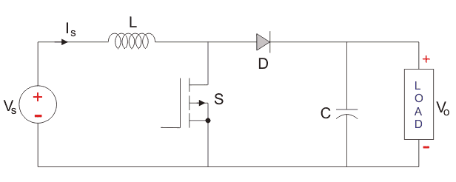

Fig 1: A Step up DC-DC converter.

1. **THEORY:**

The main working principle of boost converter is that when the switch is ON the current will flow through the switch and back to the DC input source and inductor stores energy in the form of magnetic energy and when the switch is OFF the energy stored in the inductor is released and boost the output voltage.The controlled switch is turned on and off by using Pulse Width Modulation (PWM).

In PWM switching, the switching control signal will be generated by comparing a control signal ($v_{control}$) and repetitive sawtooth waveform as shown in the Fig 2. It can be expressed the duty ratio as,

$$D=\frac{t_{on}}{T_{s}}=\frac{v_{control}}{V_{st}}$$

Where $V_{st}$ is the peak of the sawtooth waveform,

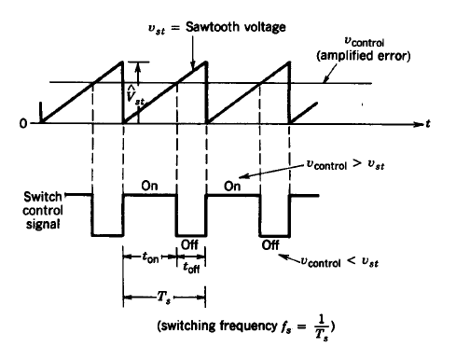

Fig 2: PWM output signal

As stated in Section 1, DC-DC converter can be operated in two different modes of operation which are called (1) Continuous Current Conduction (CCM) and (2) Discontinuous Current Conduction (DCM)

1. **Continuous Current Conduction (CCM)**

The Fig 3, shows waveform for CCM operation where inductor current flows continuously over time. In the steady state operation, the integral of the inductor voltage vL over one duty cycle must be zero. Therefore,

$${V_{d}t_{on}+ (V}_{d}-V_{o} ) t_{off}=0$$

$$\frac{V_{o}}{V_{d}}=\frac{T_{s}}{t_{off}}=\frac{1}{1-D} D=duty ratio$$

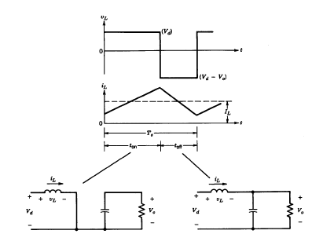

Fig 3: Step up DC-DC converter CCM mode operation.

1. **Discontinuous Current Conduction (DCM)**

The Fig. 4, In the DCM mode, the inductor current is zero during a part of the cycle. The integral of the inductor voltage over one duty cycle can be obtained as below and it is equal to zero

$${V_{d}DT_{s}+ (V}_{d}-V_{o} ) ∆_{1}T_{s}=0$$

$$\frac{V_{o}}{V_{d}}=\frac{∆_{1}+D}{∆_{1}} D=duty ratio$$

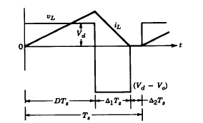

Fig 4: Step up DC-DC converter DCM mode operation.

1. **SIMULATION MODEL:**

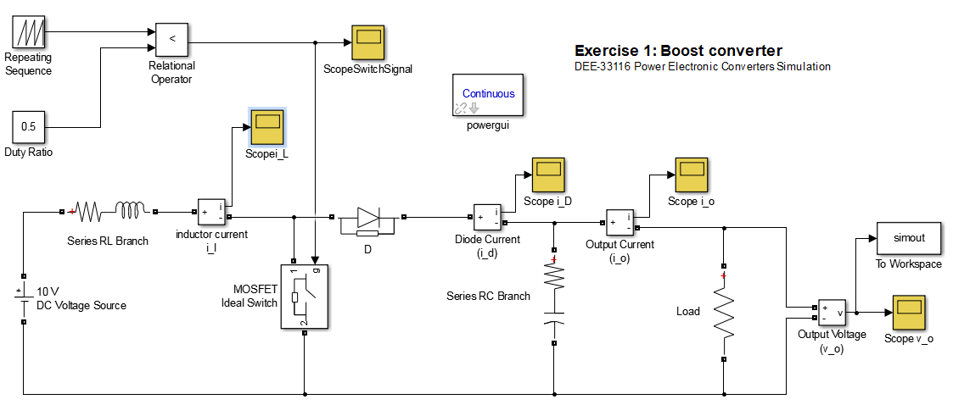

Fig 5: MATLab Simulation Model of DC-DC Boost Converter.

The simulation model is created by using the conventional Simulink-blocks and Simscape library (i.e.: DC voltage source, series RLC branch, current measurement, ideal switch, diode etc.), the model is shown in Fig. 5.

**Component Parameters:**

The given component parameters:

- DC voltage source amplitude 10V

- Inductor inductance 10mH and internal resistance 1Ω

- Capacitor capacitance 100μF and internal resistance 20mΩ

- MOSFET on-time resistance 0,01Ω and snubber resistance 1e10Ω

- Diode on-time resistance 0,01Ω and snubber resistance 1e5Ω

- Load resistor 470Ω

**PWM:**

- Square wave time values [0 1e-4] and output values [0 1]

- Duty ratio 0.5

- Relational operator =<

**Simulation Parameters:**

- Simulation stop time 5e-3

- Solver type: Variable step

- Additional options: Max step size 1e-6, Initial step size 1e-6 and Relative tolerance1e-5

- Diagnostics -> Connectivity -> Mux blocks used to create bus signals: error

**N.B:** For the steady state value we have used Simulation stop time 200e-3

1. **RESULTS:**
   1. **What is the switching frequency of MOSFET?**

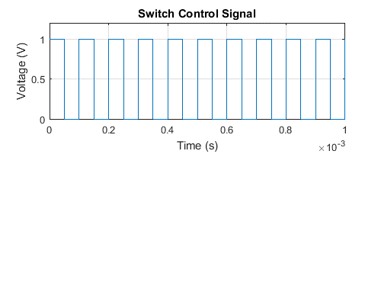

Fig 6: Switch Control Signal.

From Fig 6,there are 10 cycles within 1ms. Therefore, switching frequency of the MOSFET is 10 kHz.

**4.2 Why the resistances are added to models of inductor and capacitor?**

Practically, inductors and capacitors present internal resistance component other than inductance and capacitance. It can be clearly analyzed the effect of that resistance when simulate the circuit other than pen and paper works. Therefore, in this simulation, it has been considered the internal resistance of those components. The effect of resistor can be analyzed as below

**4.3 What is the output voltage value of boost converter when the input voltage is 10V andduty ratio D = 0.5?**

Average Output Voltage – Calculatedvalue:

$V_{0}= \frac{V_{in}}{ 1-D}= \frac{10}{1-0.5}$ = 20V

Average Output Voltage –Value from the simulation results:

$V_{0}$ = 19.03 V

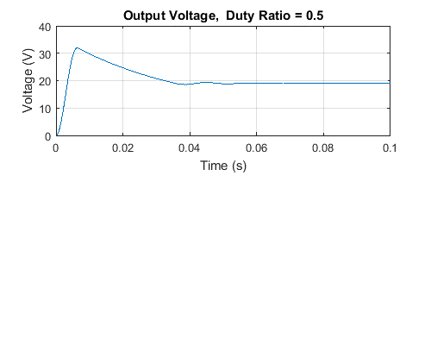

(a)

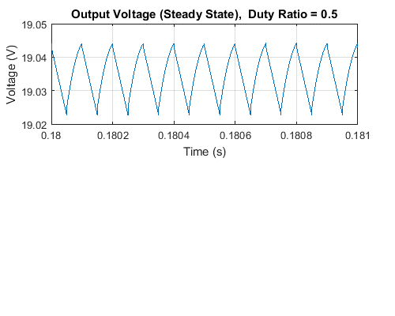

(b)

Fig 6: Output voltage of the converter when D=0.5 (a) Including transient period (b) In steady state

According to Fig 6 (a), the expected theoretical output voltage value (20V) from the simulations is slightly lower (19.03 V), and this may cause due to the internal resistance of the passive components and voltage drop.

* 1. **Calculate the inductor current average value and current ripple by using the following parameters. Do you get the same values by using the simulation model?**

Average Inductor Current – Calculative Value:

$I_{L}= \frac{I_{0}}{ 1-D}= \frac{(20/470)}{1-0.5}$ =0.085A

Current ripple for Ton,

= = 0.1ms

$${\hat{i}}_{L-pp}= \frac{V_{in}}{L}{DT}_{s}= \frac{10}{10 x {10}^{-3}} . 0.5 . 0.1x {10}^{-3} = 0.05A$$

Average Inductor Current – Simulation Results:

$$I_{L}=0.081A$$

${\hat{i}}_{L-pp}=0.49$ A

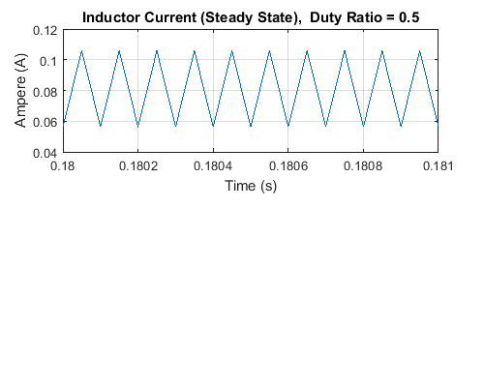

Fig 7: Inductor current, when D=0.5

The simulation values have small deviate (0.081A, 0.049A)lower than the theoretical values (0.085A,0.05A) due to the internal resistance of the inductor.

**4.5 Change the duty ratio to be D = 0.3. What is now the output voltage value of boost  
converter?**

Average Output Voltage – Calculative Value:

$V_{0}= \frac{V_{in}}{ 1-D}= \frac{10}{1-0.3}$ ≈ 14.29V

AverageOutput Voltage – Simulation Results:

$V_{0}$ = 13.43V

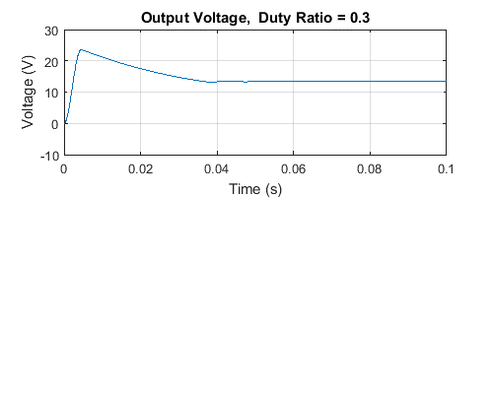

(a)

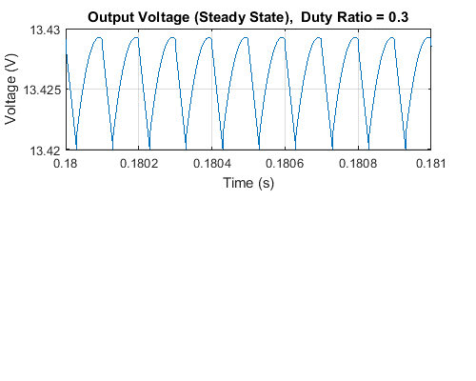

(b)

Fig 8: Output voltage of the converter when D=0.3 (a) Including transient period (b) In steady state

The above Fig8. Shows the output voltage of the boost converter for the duty cycle 0.3, As in question 4.3, the expected theoretical output voltage value (14.29 V) from the simulations is slightly lower (13.43V).

**4.6 Change the value of the passive components and the switching frequency of MOSFET. Analyze the effect on inductor current and output voltage ripple. What happens if the inductance value is very small (DCM operating mode)?**

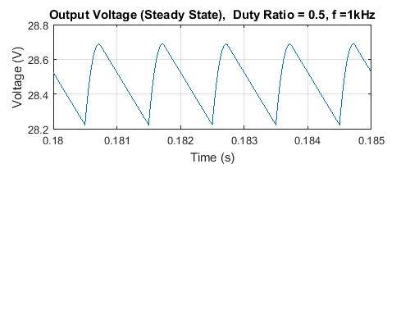

(a)

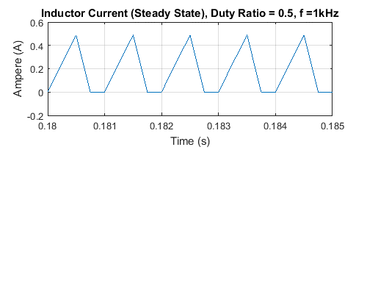

(b)

Fig 9: (a) Output voltage and (b) Inductor current when switching frequency is 1kHz

When the switching frequency is decreasing, the turn on time is varied and controllability is reduced. Normally, corner frequency of the low pass filter is selected such that being much lower than the switching frequency. But decreasing the switching frequency might, it get closer to the low pass filter range and therefore, will present high peak to peak ripple in the output voltage compared to the previous analysis and, due to the lack of the contrbility, output voltage and inductor current will be increased for a same duty ratio as in Figure 9. Vice versa, increasing the switching frequency cause effective low pass filtering and reducing the voltage ripples.

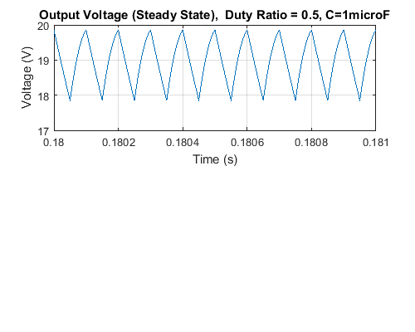

(a)

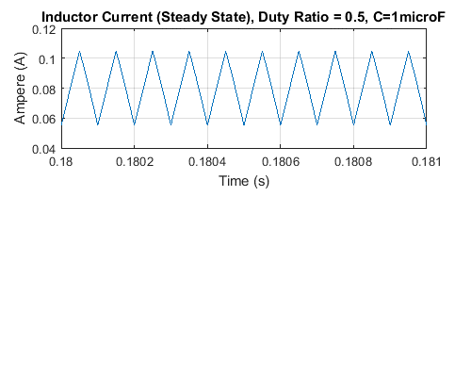

(b)

Fig 10: (a) Output voltage and (b) Inductor current when switching frequency is C = 1µF

In the previous analysis output capacitor was 100µF. With compared to that, when the capacitance is reducing the peak to peak output voltage ripple is increased. In other words, if the capacitor is large enough the output voltage tends to be constant (V (t) = Vo). In Fig 10, shows the simulation result when C = 1µF in continuous current conduction mode. Analysis will be same for the discontinuous conduction mode

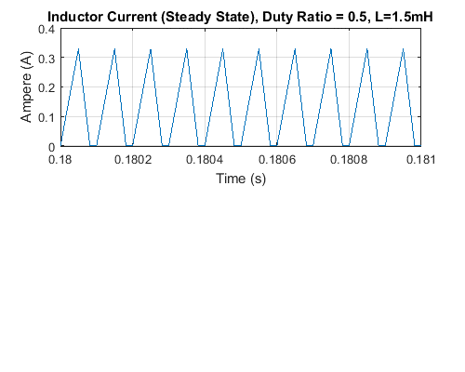

(a)

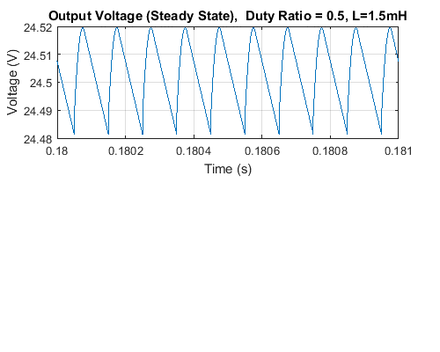

**(a)**

(b)

Fig 11: (a) Output voltage and (b) Inductor current when switching frequency is L = 1.5mH

Practically, the circuit is controlled by varying D in order to keep output voltage is constant. But for the analysis, it has been kept input voltage (Vd) and D constant. When the inductance value is kept reducing, maximum boundary current and peak inductor current is increased for same duty ratio and goes to discontinuous operation mode (Fig 11).

In practice, it should be required to keep Vo constant by varying D when change the inductance, if not Vo will be increased until reach to an energy balance and sometime may cause the capacitor damage or expose to a dangerously high voltage

**4.7 Why it is crucial to set the correct simulation step size? Test e.g the values of 1e-2 and 1e-7 to the maximum simulation step size. Test the operation of the simulation model with variable and constant simulation time step**

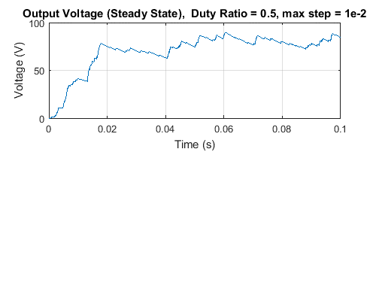

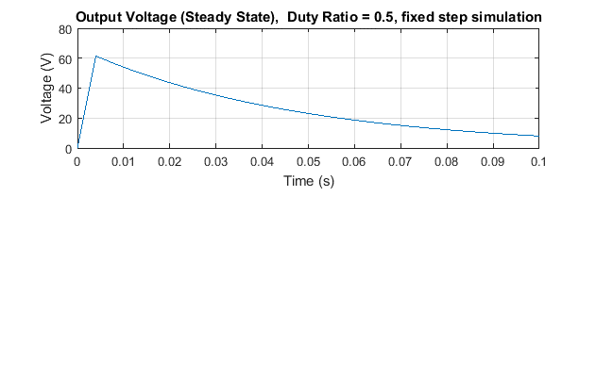**(a)**

**(b)**

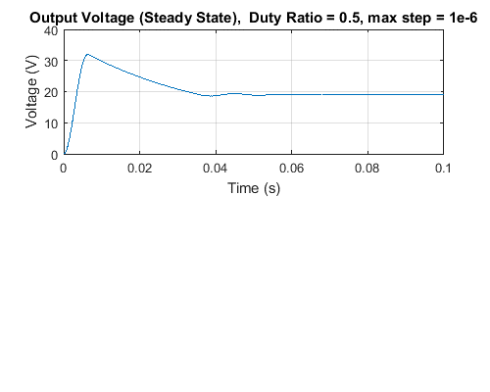

**(c)**

Fig 12: Output voltage (a) When variable solver, maximum step size = 1e-6s (b) When variable solver, maximum step size = 1e-2s, (c) When fixed solver settings

For variable-step solvers, there is a **maximum simulation step size**parameter and it controls the largest time step that solver can use during the simulation.In Fig 12 (a) and (b), presents the same simulation model results with a maximum step size of 1e-6s and 1e-2s. A considerable high step size will give an accurate result as in figures. Variable solvers,can vary the step size and handle the accuracy when system's states are changing. But, for constant simulation time step (fixed-step solvers), there is a fixed step size and solve the model for a given or auto defined step size.These solvers solve a model with fixed time steps from the simulation beginning to the end. It can be clearly seen the distortion of the output voltagein Fig 12 (b) with compared to the variable step solver results with a maximum step size of 1e-6s.However, selecting the right solver and step size can be varied according to the type of the system and application.

1. **CONCLUSION:**

We have analyzed the system with various parameters and observed the boost converter behavior by scope system of MATLab. At first the system was complicated to us but we have analyzed and gradually we understood the system behaviors with different parameters. We have tried to explain all the parameters changes and graphs.

At last we also made some MATLab coding to plot the figures so that we can take a close look on the simulation figures.

**MATLAB SCRIPTS RELATED TO PLOT WAVEFORMS**

% plot Switch Control Signal

figure(1);

set(gcf,'Position', [100, 100, 500, 400]);

set(gcf,'color','w');

subplot(2,1,1);

plot(scopeswitching.time, scopeswitching.signals.values(:));

grid on;

title('Switch Control Signal');

xlabel('Time (s)');

ylabel('Voltage (V)');

xlim([0 10e-4]);

ylim([0 1.2]);

shg;

% plot Output voltage waveform

figure(2);

set(gcf,'Position', [100, 100, 500, 400]);

set(gcf,'color','w');

subplot(2,1,1);

plot(output.time, output.signals.values(:));

grid on;

title('Output Voltage, Duty Ratio = 0.5');

xlabel('Time (s)');

ylabel('Voltage (V)');

xlim([0 0.1]);

shg;

% plot Output Voltage (Steady State) waveform

figure(3);

set(gcf,'Position', [100, 100, 500, 400]);

set(gcf,'color','w');

subplot(2,1,1);

plot(output.time, output.signals.values(:));

grid on;

title('Output Voltage (Steady State), Duty Ratio = 0.5');

xlabel('Time (s)');

ylabel('Voltage (V)');

xlim([0.18 0.181]);

shg;

% plot Inductor Current (Steady State)

figure(5);

set(gcf,'Position', [100, 100, 500, 400]);

set(gcf,'color','w');

subplot(2,1,1);

plot(iL.time, iL.signals.values(:));

grid on;

title('Inductor Current (Steady State), Duty Ratio = 0.5');

xlabel('Time (s)');

ylabel('Ampere (A)');

xlim([0.18 0.181]);

shg;

% plot Output voltage waveform

figure(4);

set(gcf,'Position', [100, 100, 500, 400]);

set(gcf,'color','w');

subplot(2,1,1);

plot(output.time, output.signals.values(:));

grid on;

title('Output Voltage, Duty Ratio = 0.3');

xlabel('Time (s)');

ylabel('Voltage (V)');

xlim([0 0.1]);

shg;

% plot Output Voltage (Steady State) waveform

figure(5);

set(gcf,'Position', [100, 100, 500, 400]);

set(gcf,'color','w');

subplot(2,1,1);

plot(output.time, output.signals.values(:));

grid on;

title('Output Voltage (Steady State), Duty Ratio = 0.3');

xlabel('Time (s)');

ylabel('Voltage (V)');

xlim([0.18 0.181]);

shg;

% plot Inductor Current (Steady State) - L=1.5mH

figure(5);

set(gcf,'Position', [100, 100, 500, 400]);

set(gcf,'color','w');

subplot(2,1,1);

plot(iL.time, iL.signals.values(:));

grid on;

title('Inductor Current (Steady State), Duty Ratio = 0.5, L=1.5mH');

xlabel('Time (s)');

ylabel('Ampere (A)');

xlim([0.18 0.181]);

shg;

% plot Output Voltage (Steady State) waveform - L=1.5mH

figure(6);

set(gcf,'Position', [100, 100, 500, 400]);

set(gcf,'color','w');

subplot(2,1,1);

plot(output.time, output.signals.values(:));

grid on;

title('Output Voltage (Steady State), Duty Ratio = 0.5, L=1.5mH');

xlabel('Time (s)');

ylabel('Voltage (V)');

xlim([0.18 0.181]);

shg;

% plot Inductor Current (Steady State) - C=1microF

figure(7);

set(gcf,'Position', [100, 100, 500, 400]);

set(gcf,'color','w');

subplot(2,1,1);

plot(iL.time, iL.signals.values(:));

grid on;

title('Inductor Current (Steady State), Duty Ratio = 0.5, C=1microF');

xlabel('Time (s)');

ylabel('Ampere (A)');

xlim([0.18 0.181]);

shg;

% plot Output Voltage (Steady State) waveform - C=1microF

figure(4);

set(gcf,'Position', [100, 100, 500, 400]);

set(gcf,'color','w');

subplot(2,1,1);

plot(output.time, output.signals.values(:));

grid on;

title('Output Voltage (Steady State), Duty Ratio = 0.5, C=1microF');

xlabel('Time (s)');

ylabel('Voltage (V)');

xlim([0.18 0.181]);

shg;

% plot Inductor Current (Steady State) - f =1kHz

figure(8);

set(gcf,'Position', [100, 100, 500, 400]);

set(gcf,'color','w');

subplot(2,1,1);

plot(iL.time, iL.signals.values(:));

grid on;

title('Inductor Current (Steady State), Duty Ratio = 0.5, f =1kHz');

xlabel('Time (s)');

ylabel('Ampere (A)');

xlim([0.18 0.185]);

shg;

% plot Output Voltage (Steady State) waveform - f =1kHz

figure(4);

set(gcf,'Position', [100, 100, 500, 400]);

set(gcf,'color','w');

subplot(2,1,1);

plot(output.time, output.signals.values(:));

grid on;

title('Output Voltage (Steady State), Duty Ratio = 0.5, f =1kHz');

xlabel('Time (s)');

ylabel('Voltage (V)');

xlim([0.18 0.185]);

shg;

% plot Output Voltage (Steady State) waveform max step = 1e-2

figure(9);

set(gcf,'Position', [100, 100, 500, 400]);

set(gcf,'color','w');

subplot(2,1,1);

plot(output.time, output.signals.values(:));

grid on;

title('Output Voltage (Steady State), Duty Ratio = 0.5, max step = 1e-2');

xlabel('Time (s)');

ylabel('Voltage (V)');

xlim([0 0.1]);

shg;

% plot Output Voltage (Steady State) waveform max step = 1e-6

figure(10);

set(gcf,'Position', [100, 100, 500, 400]);

set(gcf,'color','w');

subplot(2,1,1);

plot(output.time, output.signals.values(:));

grid on;

title('Output Voltage (Steady State), Duty Ratio = 0.5, max step = 1e-6');

xlabel('Time (s)');

ylabel('Voltage (V)');

xlim([0 0.1]);

shg;

1. **REFERENCES:**

[1] Mohan, N., Undeland, T. M., & Robbins, W. P. (2007). *Power electronics: Converters, applications, and design*. New Delhi, India: John Wiley & Sons.

[2] Hart, D. W. (2006). *Introduction to power electronics*. Valparaiso, IN: Daniel W. Hart.